Here we have a website named Green Village Initiatibve.

With with this website, we aim to increase the engagement and initiatives of the green village organization which is a non profit- village helping charitable organization.

The homepage of the website looks like this with the very cool logo at the top showing what the website offers along with the name of the website and the volunteering button

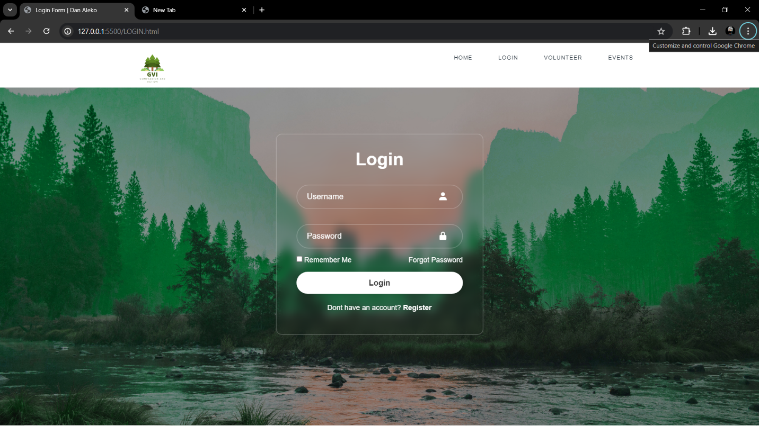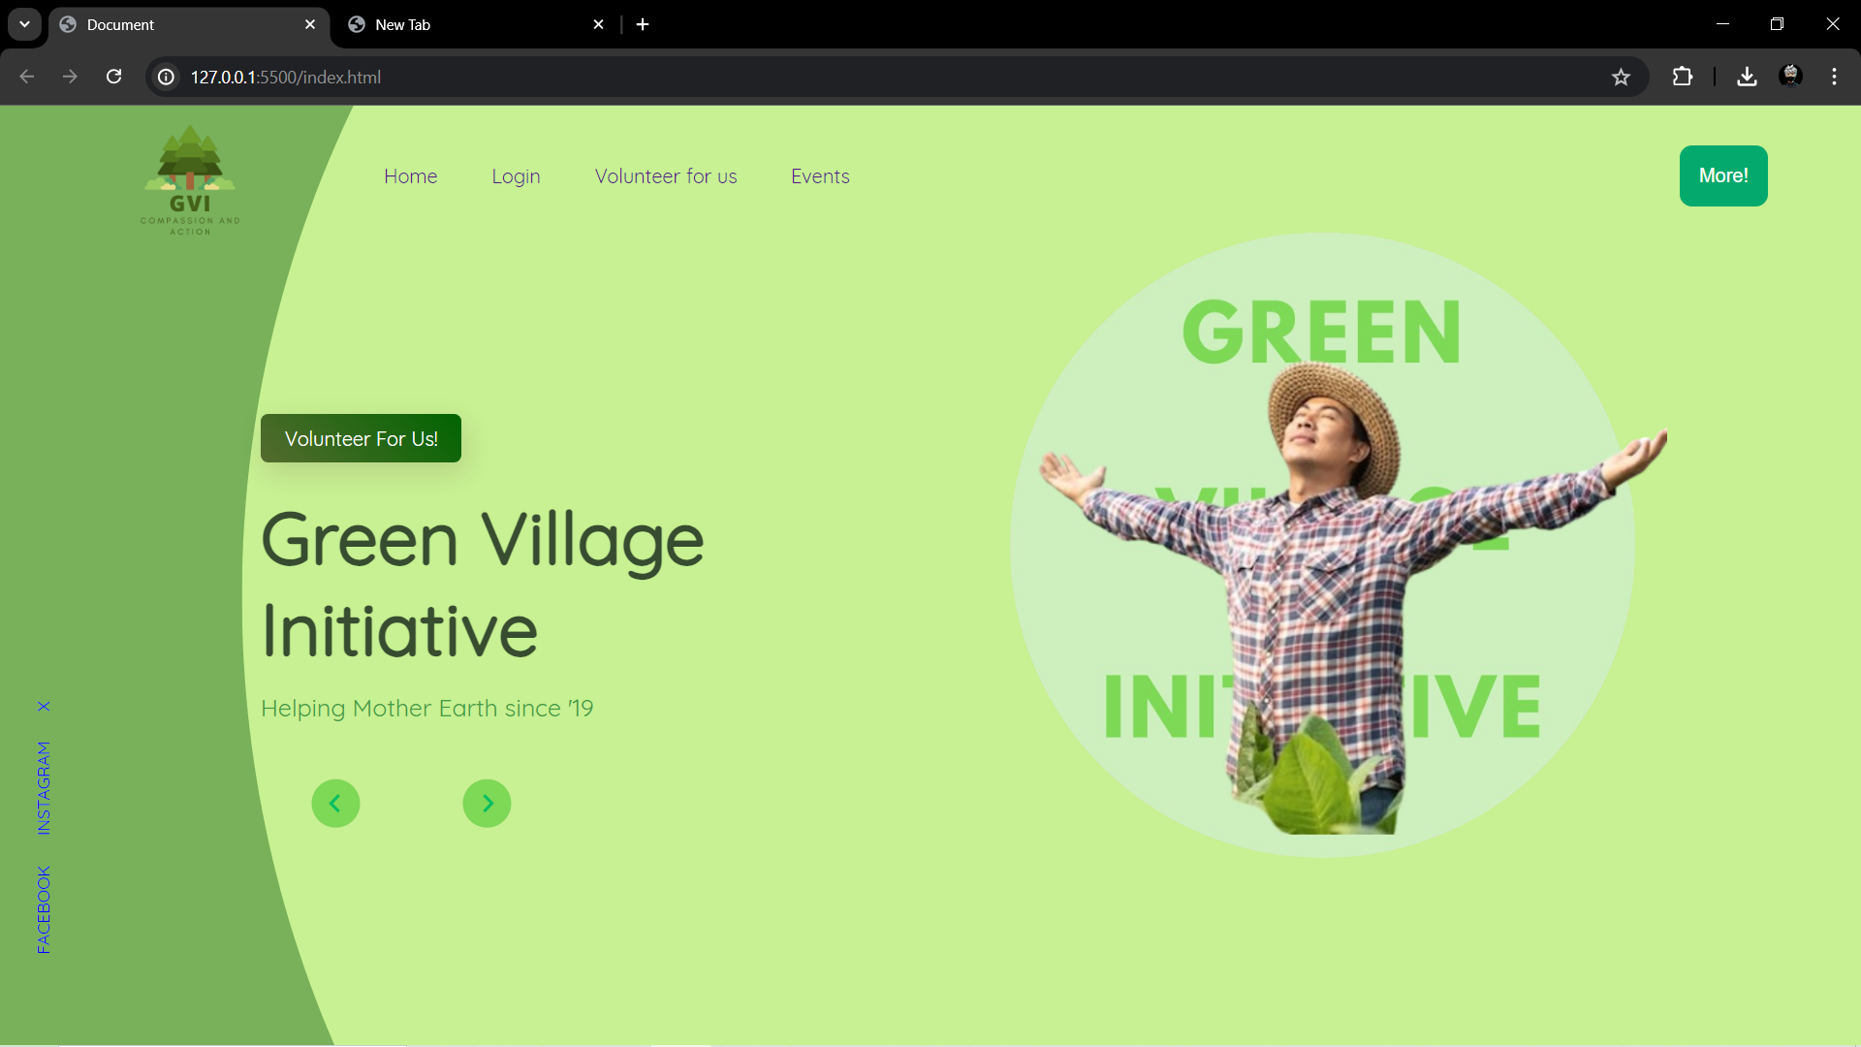

The page below is the login page which has the login buttons which helps a user to sign into the website and help the ngo as a volunteer. A person just looking through the website can also just login to continue his experience

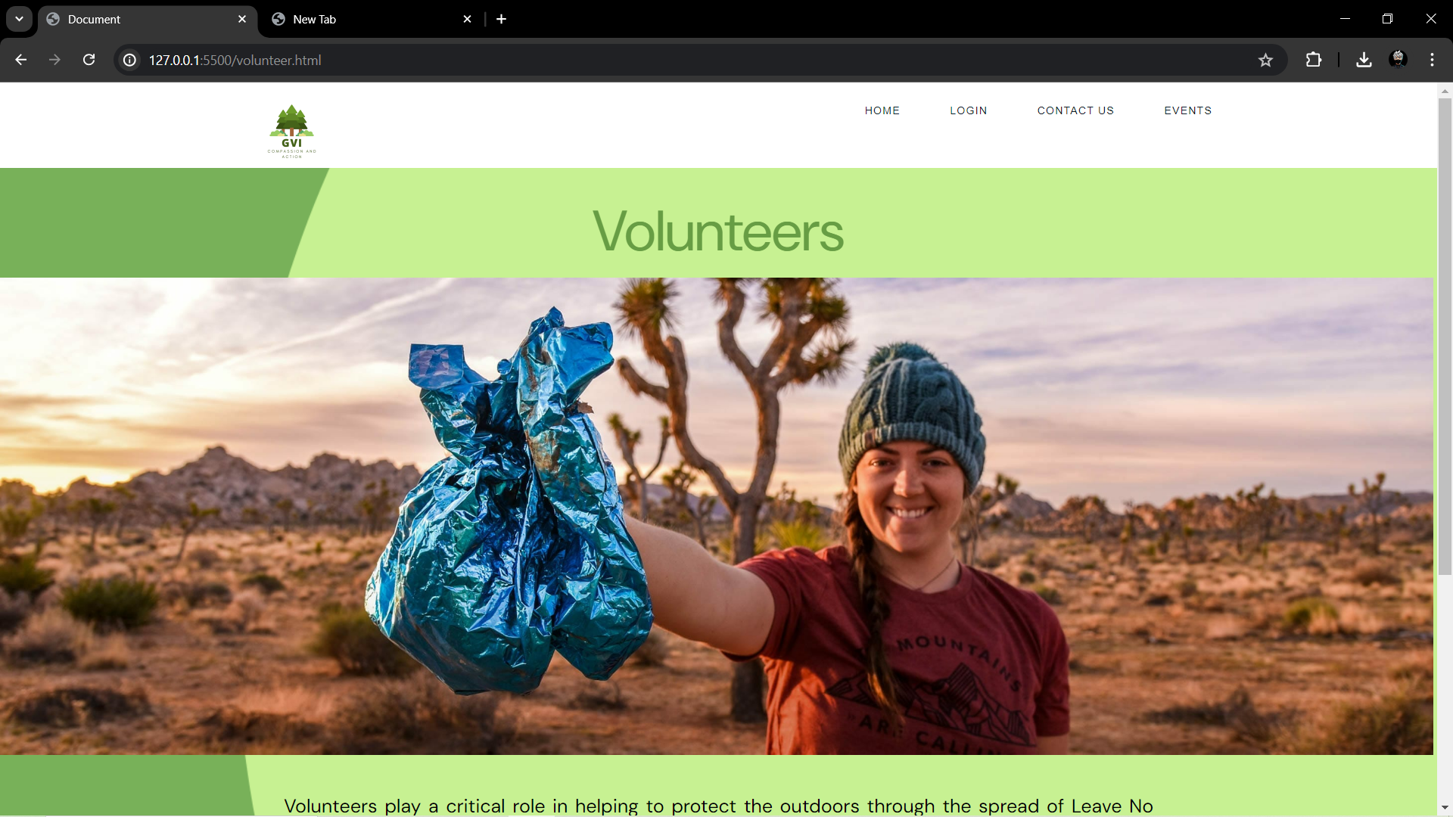

This is the volunteers page along with an image to provoke people.the page has 2 buttons, 1 to subscribe to the letter on mail. And 1 to fill a form and volunteer for the ngo

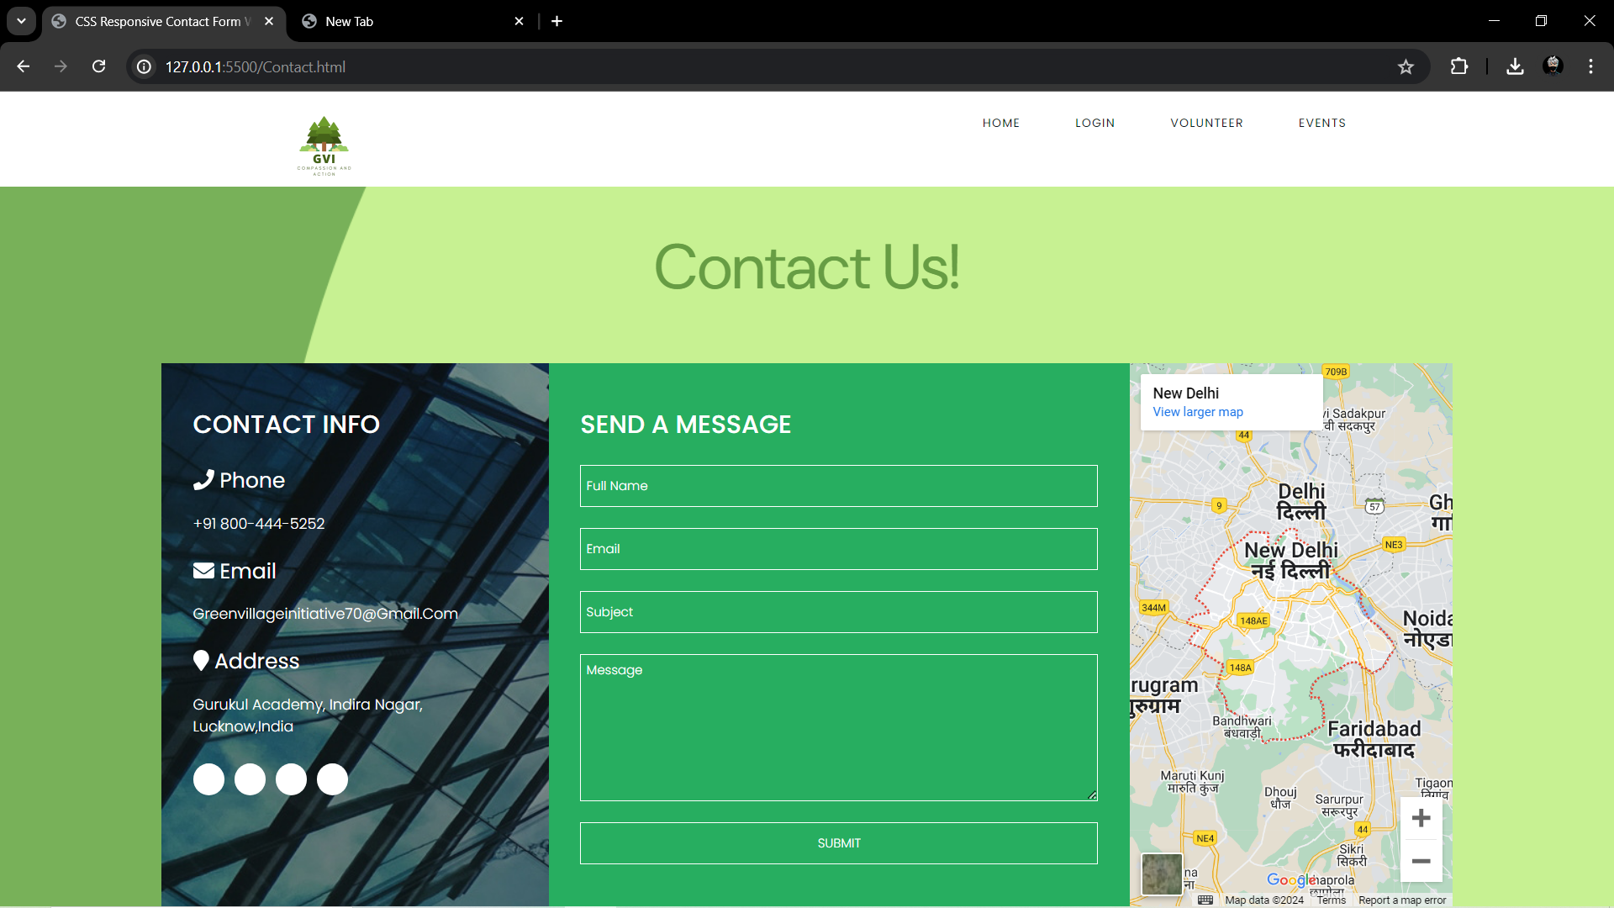

This is the contact page. it helps the user to contact the ngo officials easily through his/her mail id. The phone number and the email id of the ngo has been listed on the left along ith an interactive map on the left side. Thia map shos the office of the ngo.

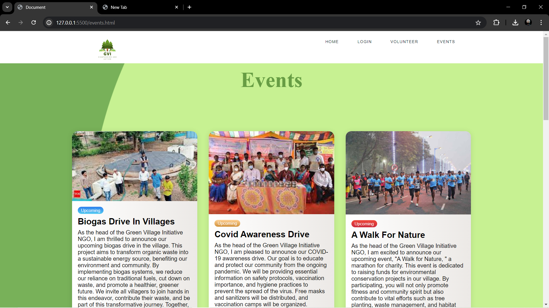

The events page helps us to see the events the ngo has hosted and the upcoming events that are yet to be started by the ngo organization. They are marked by a spanner class named upcoming for upcoming events and the other class for the other not started events.

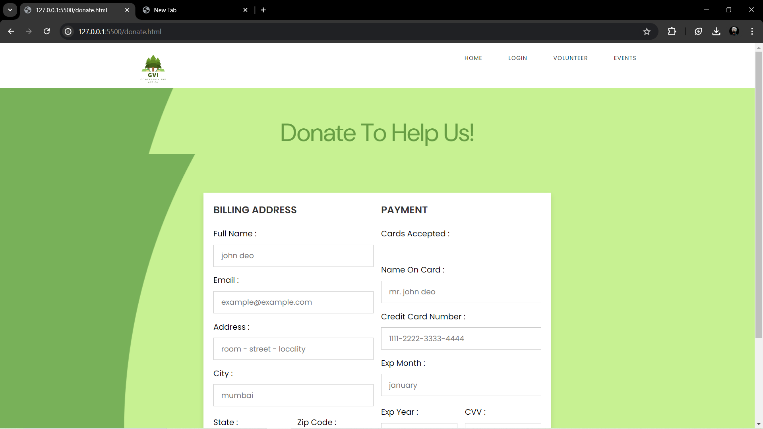

This page helps the user to donate to the ngo ithout being a volunteer and help the ngo. The people ho do this are kind hearted people

* COMPLICATIONS

Our team faced many complications regarding the site as this is our first hackathon,

Any[w](https://search.yahoo.com/search?fr=mcafee&type=E210US714G0&fr2=p%3As%2Cv%3Aw%2Cm%3Ars-algo%2Cct%3Agossip&p=website%20development)ays, this [w](https://search.yahoo.com/search?fr=mcafee&type=E210US714G0&fr2=p%3As%2Cv%3Aw%2Cm%3Ars-algo%2Cct%3Agossip&p=website%20development)ebsite helped us to learn more and even if [w](https://search.yahoo.com/search?fr=mcafee&type=E210US714G0&fr2=p%3As%2Cv%3Aw%2Cm%3Ars-algo%2Cct%3Agossip&p=website%20development)e don’t [w](https://search.yahoo.com/search?fr=mcafee&type=E210US714G0&fr2=p%3As%2Cv%3Aw%2Cm%3Ars-algo%2Cct%3Agossip&p=website%20development)in, [w](https://search.yahoo.com/search?fr=mcafee&type=E210US714G0&fr2=p%3As%2Cv%3Aw%2Cm%3Ars-algo%2Cct%3Agossip&p=website%20development)e [w](https://search.yahoo.com/search?fr=mcafee&type=E210US714G0&fr2=p%3As%2Cv%3Aw%2Cm%3Ars-algo%2Cct%3Agossip&p=website%20development)ill go home [w](https://search.yahoo.com/search?fr=mcafee&type=E210US714G0&fr2=p%3As%2Cv%3Aw%2Cm%3Ars-algo%2Cct%3Agossip&p=website%20development)ith loads of learning

[w](https://search.yahoo.com/search?fr=mcafee&type=E210US714G0&fr2=p%3As%2Cv%3Aw%2Cm%3Ars-algo%2Cct%3Agossip&p=website%20development)e faced problems in finding the right tool to record out videos and free hosting sites

our team faced complications in ho[w](https://search.yahoo.com/search?fr=mcafee&type=E210US714G0&fr2=p%3As%2Cv%3Aw%2Cm%3Ars-algo%2Cct%3Agossip&p=website%20development) to use the google maps api but it ended up [w](https://search.yahoo.com/search?fr=mcafee&type=E210US714G0&fr2=p%3As%2Cv%3Aw%2Cm%3Ars-algo%2Cct%3Agossip&p=website%20development)orking somehow.

This was my first time sitting for 7+ hours and coding and this was a fun experience!